***Gas Leakage monitoring & Alerting system for Industries***

**SPRINT - 3**

|  |  |
| --- | --- |
| TEAM ID | PNT2022TMID04012 |
| DATE | 14TH NOVEMBER 2022 |

IBM Watson IoT platform, Workflows for IoT scenarios using Node-red: Building Project:

Connecting IOT Simulator to IBM Watson IOTPlatform Give the credentials of your device in IBM Watson "orgId": "wv4o8f",

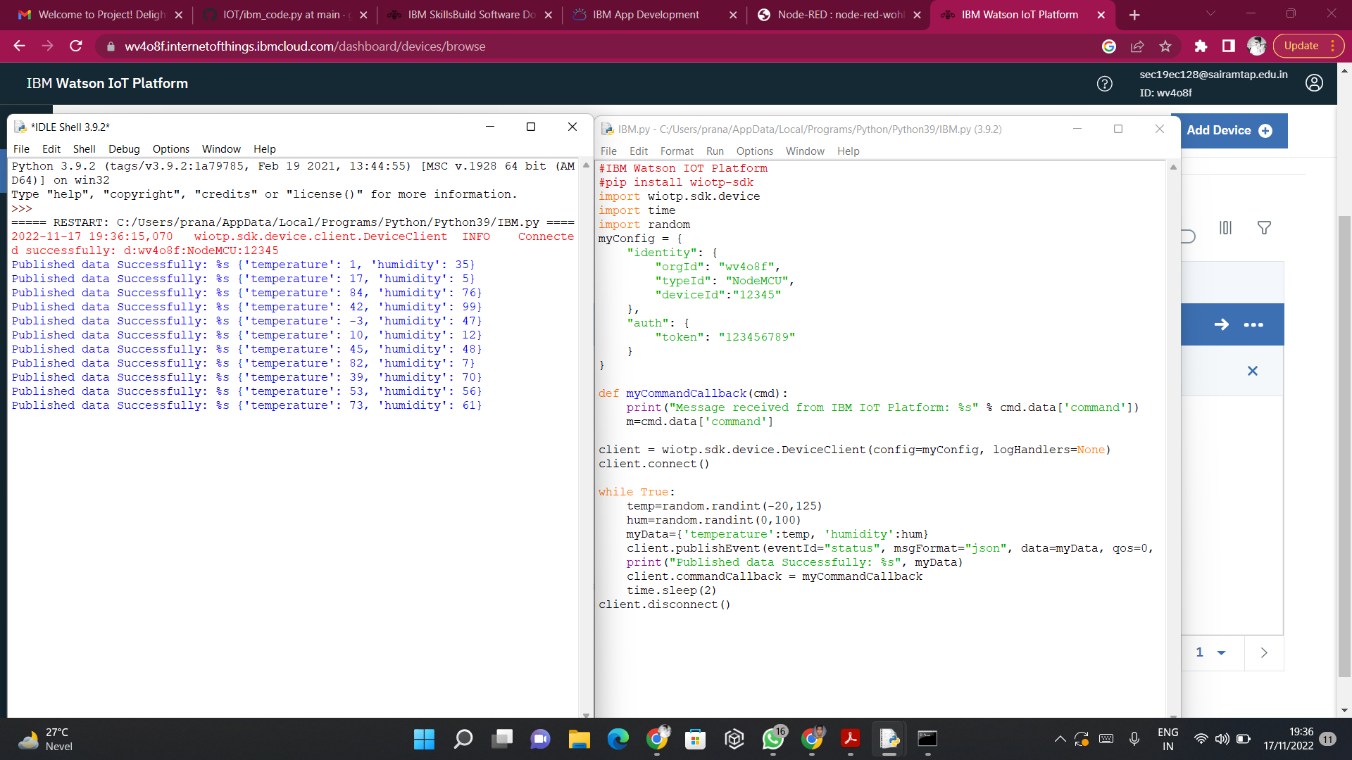"typeId": "NodeMCU", "deviceId": "12345"

The node IBM IOT App In is added to Node-Red workflow. Then the appropriate device credentials obtained earlier are entered into the node to connect and fetch device telemetry to Node-Red

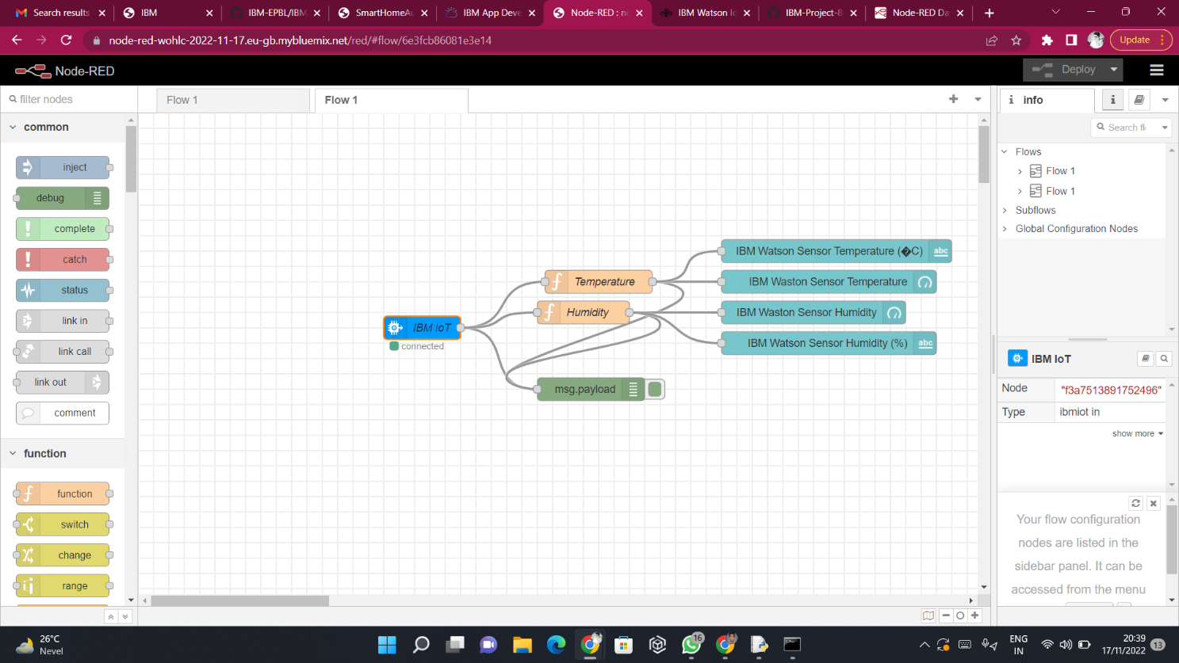

The Node-Red also receive data from the Open Weather API by HTTP GET request. An inject trigger is added to perform HTTP request for every certain interval. HTTP request node is configured with URL we saved before.

